Advertisement No. NABI/ADMIN/1(001)/2022-23-01/Rectt

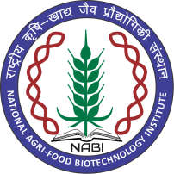
राष्ट्रीय कृषि खाद्य जैव प्रौद्योगिकी संस्थान
(NATIONAL AGRI-FOOD BIOTECHNOLOGY INSTITUTE)
(जैव प्रौद्योगिकी विभाग, विज्ञान और प्रौद्योगिकी मंत्रालय, भारत सरकार)

SR. PRIVATE SECRETARY (UR-01), (POST CODE-2001)
Referring to the advertisement NABI/ADMIN/1(001)/2022-23-01/Rectt for Sr. Private Secretary one below mentioned candidate has been provisionally shortlisted.
Application ID-22PS0096
The position will be re-advertised due to insufficient candidates shortlisted for further selection process.

Manager - Admin

