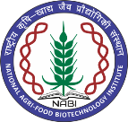
NATIONAL AGRI-FOOD BIOTECHNOLOGY INSTITUTE
(Autonomous Institute of Dept. of Biotechnology, Ministry of Science & Technology, Govt. of India) Knowledge City, Sector-81, Mohali

Result of Online interview held on 21-05-2024

Field Assistant
Sr. No. | Name of the Candidate | Remarks
1. | Dr. Nidhi Yadav | Selected
2. | Dr. S. Ellairaja | Waitlisted
3. | Dr. Vijendra Singh | Waitlisted

X—X—X—X

