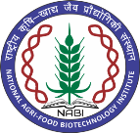
NATIONAL AGRI-FOOD BIOTECHNOLOGY INSTITUTE
(Autonomous Institute of Dept. of Biotechnology, Ministry of Science & Technology, Govt. of India) Knowledge City, Sector-81, Mohali

Result of online interview held on 21-02-2024

Research Associate - I

Sr. No. | Name of the Candidate | Remarks
1. | Ms. Joshi Priyanka S. | Selected
2. | Ms. Aditi Sharma | Waitlist -1

X—X—X—X

