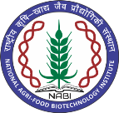**NATIONAL AGRI-FOOD BIOTECHNOLOGY INSTITUTE**

**(Autonomous Institute of Dept. of Biotechnology, Ministry of Science & Technology, Govt. of India) Knowledge City, Sector-81, Mohali**

**Result of interview held on 30-08-2024**

|  |  |  |
| --- | --- | --- |
| **Lab Animal Veterinarian (NABI Core Grant)** | | |
| **क्र. सं.** | **उम्मीदवार का नाम** | **टिप्पणी** |
| 1. | Sh. Drishiya Vats | Selected |
| 2. | Sh. Digvijay Singh | Waitlisted |

X—X—X—X