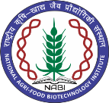
NATIONAL AGRI-FOOD BIOTECHNOLOGY INSTITUTE
(Autonomous Institute of Dept. of Biotechnology, Ministry of Science & Technology, Govt. of India) Knowledge City, Sector-81, Mohali

Result of online / Walk-in-interview held on 06-02-2024

JRF (GAP-66)

Sr. No. | Name of the Candidate | Remarks
1. | None found suitable

Project Scientist (GAP -65)

Sr. No. | Name of the Candidate | Remarks
1. | Dr. Balamurugan A. | Selected
2. | Dr. Tilak Chandra | Waitlist -1

X—X—X—X

