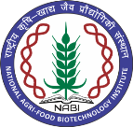
NATIONAL AGRI-FOOD BIOTECHNOLOGY INSTITUTE
(Autonomous Institute of Dept. of Biotechnology, Ministry of Science & Technology, Govt. of India) Knowledge City, Sector-81, Mohali

Result of Walk-in-interview held on 08-05-2024

Field Assistant
Sr. No. | Name of the Candidate | Remarks
1. | Ms. Vannam Anjali | Selected
2. | Gurleen Kaur | Waitlisted

X—X—X—X

