
National Agri-Food and Biomanufacturing Institute (NABI)
(An Autonomous institute of the Department of Biotechnology,
Ministry of Science &Technology, Govt. of India)

Sector-81, Knowledge City, Mohali-140306, Punjab (INDIA)

Advertisement No. NABI/Admin/5(1)/2022-23/ACAD-07 RCB-NABI
NABI Ph.D. (Biotechnology) Program Admission January (Winter) 2026

National Agri-Food Biotechnology Institute (NABI), Mohali is inviting applications from motivated students for admission to the PhD degree program in Biotechnology for the January 2026 session. NABI is recognized as a Centre by the Regional Centre for Biotechnology (RCB), Faridabad, for conducting PhD (Biotechnology) programs. The program will be conducted at NABI, and the degree will be awarded by RCB (www.rcb.res.in), an institute of national importance established through an act of parliament.

Duration of PhD course: The duration is for 5 years and a maximum of 7 years.

Area of PhD research work: Agricultural Biotechnology, Food Biotechnology, Nutrition Biotechnology, Bioprocessing, Secondary agriculture and valorization, Biomanufacturing, Plant Molecular Biology, Bioinformatics, Nanobiosciences, Post-harvest technology, Functional foods, Genomics and Computational Biology.

Number of Seats: 36 (Reservation of seats, as per GOI guidelines)

Eligibility Criteria:

Essential qualification:

  - MSc/MTech in any area of life sciences, MPharma/ MVSc/MBBS or an equivalent degree.
  - 55% total marks or equivalent score in the qualifying degree (5% relaxation in marks will be given to SC/ST/OBC(non-creamy layer)/PWD as per GOI norms)
  - In addition to the above, candidates applying for admission must qualify a national-level test for pursuing the Doctor of Philosophy program. Such tests include doctoral fellowship or admission eligibility tests conducted at the national level by recognized government agencies, such as the University Grants Commission (UGC), Council for Scientific and Industrial Research (CSIR), Indian Council for Medical Research (ICMR), Department of Science and Technology (DST), Department of Biotechnology (DBT), NABI fellowship or any other government-recognized agency.
  - Additionally, applicants who have qualified in GATE or any other national-level examination will also be considered for admission under NABI core grant.

Candidates who have appeared or will be appearing in the qualifying degree examination (final year/final semester) and are awaiting their results are also eligible to apply. However, admission is subject to fulfilling the aforementioned criteria/requirements satisfactorily at the time of joining.

Fellowship:
- The students admitted to the program should have their own fellowship from any of the recognized granting agencies.

- In addition to this, a limited number of selected candidates who do not have their own fellowship (but with GATE or National exam qualified) may be offered the NABI-Core fellowship based on merit.
The intake of students for the January (Winter) 2026 session is 36, and the reservation of the seats will be as follows:
  - 27% seats for OBC (non-creamy layer), 15% seats for SC, 7.5% seats for ST and 5% seats for Persons with Disability (PWD) as per the reservation policy of the Government of India (with minimum disability to the extent of 40%) in pursuance of Provisions of Rights of Persons with Disabilities Act 2016. Reservation of 5% seats in respect of PWD candidates shall be done horizontally, as per the Government of India Guidelines/Policy.
  - The candidates belonging to the Economically Weaker Sections (EWSs) who are not covered under the reservation for SCs, STs, and OBCs will have 10% reservation in admissions. The candidates should submit the certificate as per Annexure – “A”.
  - All reserved category candidates are required to submit a certificate in respect of their claims from the appropriate authority as notified by the Government of India for the purpose from time to time.

Screening cum Selection Process:

Applications received ONLY through the ONLINE MODE in the prescribed format will be considered. Incomplete applications will be summarily rejected.
The consideration of qualifications as 'equivalent' to the essential qualifications stated above shall be the sole discretion of the Screening/Selection Committee.
Please note that the prescribed essential qualifications are minimum, and the mere possession of the same does not entitle any candidate to be called for the interview. Merit-based shortlisting of the candidates will be carried out by the screening committee (on a set of well-defined criteria including excellent academic credentials, own fellowship etc.). However, the institute will have the discretion to fix qualifying marks for the interview (wherever applicable).

The details of Admission, Application Form, and Ph.D. course work are available at NABI website (www.nabi.res.in).
NABI will not be held responsible for any delays or system failures that may occur at the candidate's end. The decision of NABI in all matters relating to eligibility, acceptance or rejection of the application, mode of selection and conduct of interviews will be final and binding on the candidates. For any legal dispute, the courts of law at the Honourable High court of Punjab and Haryana.

How to apply:-

The eligible candidates shall apply through online mode, and the link will be available in http://recruitment.nabi.res.in/nabiPhd/login and also upload the supporting documents as per the given format. Applications received in any mode other than online will not be accepted.
The following important dates may be noted:
1. | Start date for online submission of Application Form | 3rd February 2026
2. | Last date for submission of online Application Form and online fee | 20th February 2026 till 5:30 PM
3. | Date of Interview | Details will be updated on the website
It is advised to keep the following scanned documents ready before filling out the online application form.
(It is suggested to scan the documents from your originals. The documents should be uploaded at appropriate places)
- Photograph
- Signature
- Proof of date of birth
- Certificates for the educational qualifications.
- Fellowship Certificate including GATE fellowship or any other fellowship
- Category certificate, if any
- Any other information

If any technical assistance is required with regard to the submission of the application, the candidate may contact the ICT team through phdbiotechprog@gmail.com
If there is any Corrigendum/ Amendments in the advertisement, it shall be published on institute website only. Before applying, candidates may refer to the NABI website.
The applicants are encouraged to go through the scientists’ profile in the NABI website to identify their potential areas of interest.
To know more about ‘National Agri-Food Biotechnology Institute’, kindly visit our website
www.nabi.res.in

Manager Administration

ANNEXURE – A
GOVERNMENT OF INDIA
(NAME & ADDRESS OF THE AUTHORITY ISSUING THE CERTIFICATE)
INCOME & ASSEST CERTIFICATE TO BE PRODUCED BY ECONOMICALLY WEAKER SECTIONS

Certificate No………………..
Date……..……………………….
VALID FOR THE YEAR ………………………..

This is to certify that Shri/Smt./Kumari ……………………………. Son/daughter/wife of ………………………..
permanent resident of …………………… Village/Street Post Office District
……………….. in the State/Union Territory …………………… Pin Code whose photograph is
attested below belongs to Economically Weaker Sections, since the gross annual Income* of his/her
„family*** is below Rs. 8 lakh (Rupees Eight Lakh only) for the financial year His / her
family does not own or possess any of the following assets***;

  - 5 acres of Agricultural land and above;
  - Residential flat of 1000 sq. ft. and above;
  - Residential plot of 100 sq. yards and above notified municipalities;
  - Residential plot of 200 sq. yards and above in areas other than the notified municipalities.

2. Shri/Smt./Kumari ……………………. belongs to the caste which is not recognized as a
Scheduled Caste, Scheduled Tribe and Other Backward Classes (Central List)
Recent Passport size Attested photograph of the applicant

Signature with Seal of the office……………….……… Name: - …………………….………………………… Designation: -……………………………
*Note: Income covered all sources i.e. salary, agriculture, business, profession, etc.
**Note 2: The term “Family” for this purpose includes the person, who seeks benefit of reservation, his/her parents and siblings below the age of 18 years as also his/ her spouse and children below the age of 18 years.
***Note 3: The property held by a “Family” in different locations or different places / cities have been clubbed while applying the land or property holding test to determine EWS status.

Steps to Make Online Payment

Step 1: After completing registration, click the “Make Payment” button on the portal 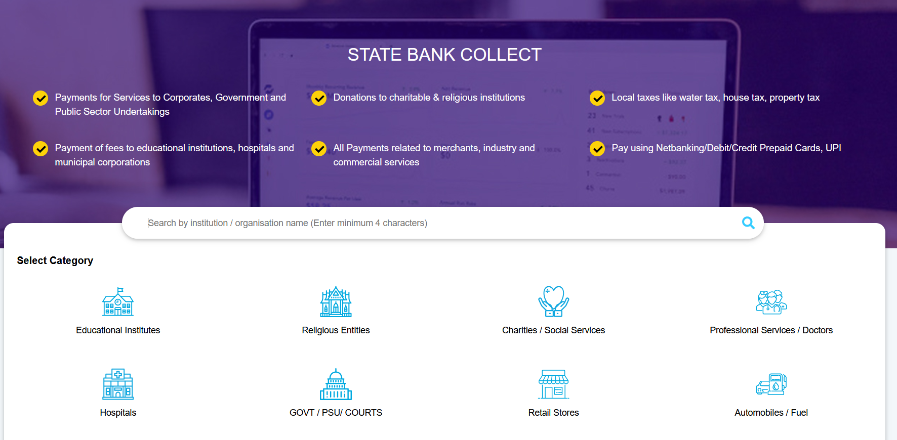

Step 2: Search ‘National Agri Food Biotechnology Institute’ in the search Bar
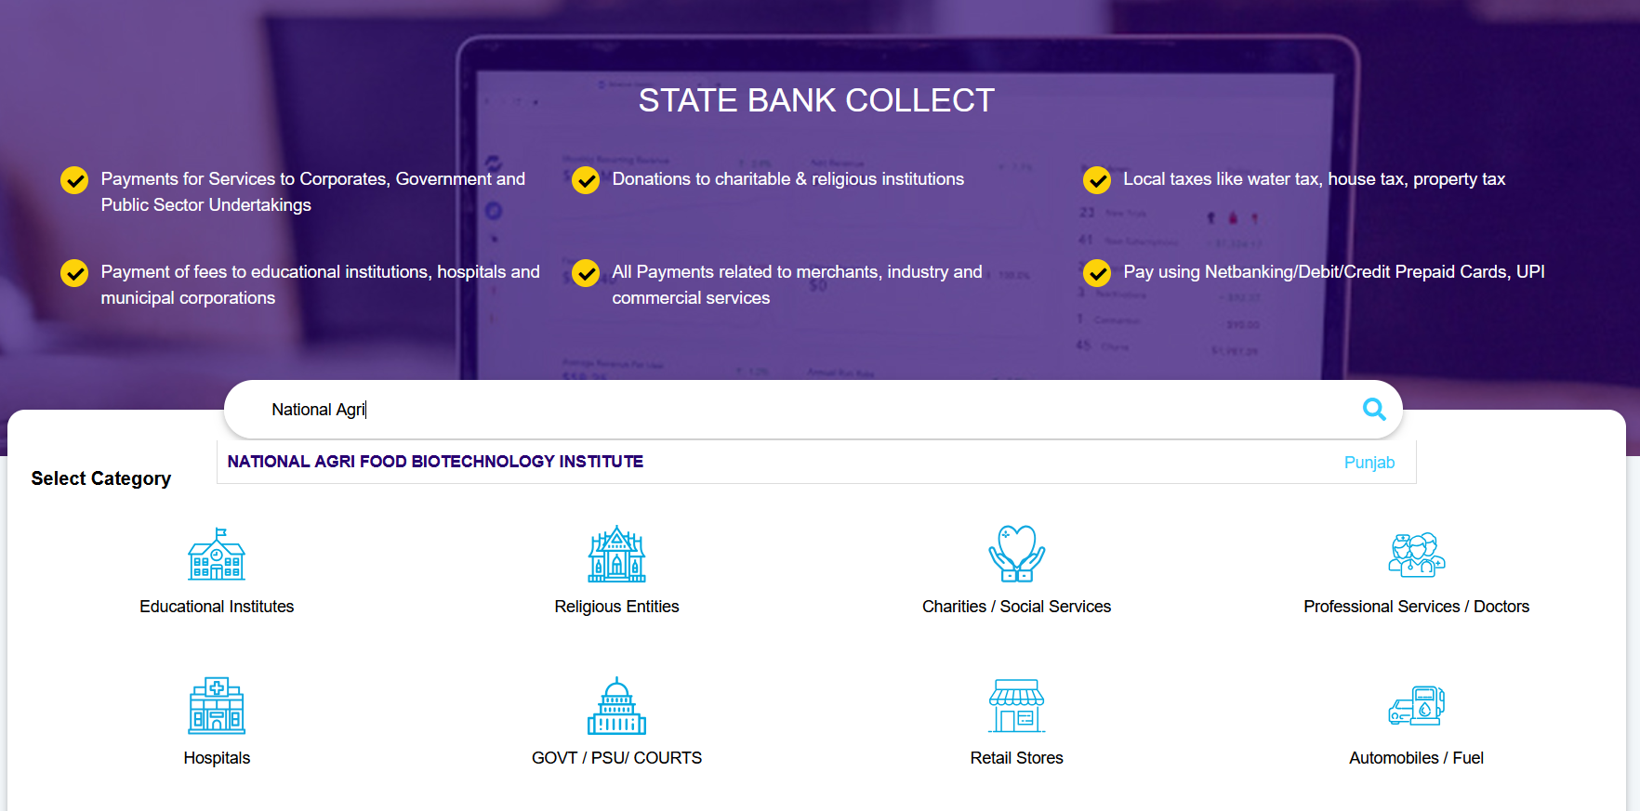

Step 3: Select your Category and Make Payment
