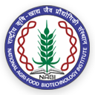
NATIONAL AGRI-FOOD BIOTECHNOLOGY INSTITUTE (NABI)
(Dept. of Biotechnology, Ministry of Science & Technology, Govt. of India) Knowledge City, Sector 81, S.A.S. Nagar, Mohali 140306, Punjab, INDIA Website: www.nabi.res.in
Under the umbrella of
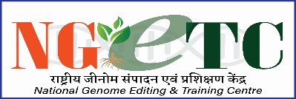
National Genome Editing and Training Centre (NGTEC)

Invites Application For 2nd Workshop
on
"Genome editing mediated by CRISPR/Cas9: Tools, experimental design and its applications"
(NGETC NABI--Series-1)
2023-24
Application Form
Name of the candidate
(In caps)

Date of birth

Gender
Current Designation

Current Affiliation

Official Address and Contact number with email:

Educational qualification: (Starting from Bachelor’s Degree onwards)
Ongoing area/s of research (<50 words)
Representative research Publications
(if any; not more than five)
Details of previously attended genome editing/functional genomics workshop (if applicable)
Why you wish to attend the genome engineering workshop?
Letter of forwarding/support from the Head of your current institute/department/college etc.

Date
Place Signature of the candidate

Instruction:
- Candidates are requested to fill in the information above properly.
- Candidates should attach the “Letter of forwarding/support from the Head of your current institute/department/college etc.” and merge the same with the application form as a pdf format and send the same at ngetcnabi@gmail.com on or before 05th August, 2023 (last date).
- The registration fees also includes the accommodation and food charges.
- Limited seats (12) are available for the above workshop.
- Once the applicant is selected they will be informed via email. Subsequent to this the candidate will have to deposit the registration fees and need to send the proof of the deposit at the above email ID. No request to waive-off the registration fees will be considered.
- No travel related arrangements will be entertained.

