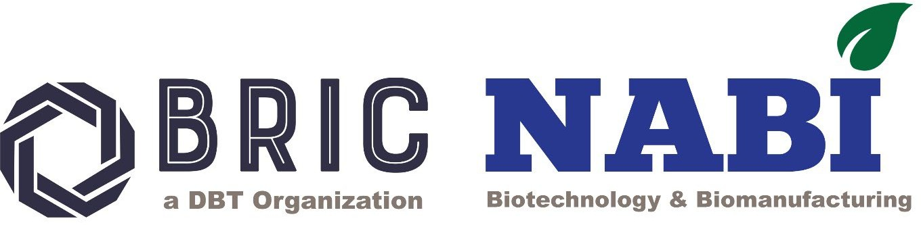

NATIONAL AGRI-FOOD AND BIOMANUFACTURING INSTITUTE (BRIC-NABI)

**(De pt. of Biotechnology, Ministry of Scie nce & Technology, Govt. of India) Knowle dge City, Sector 81, S.A.S. Nagar, Mohali 140306, Punjab, INDIA Website:** [**www.nabi.res.in**](http://www.nabi.res.in/)

***Under the umbrella of***

**National Genome Editing and Training Centre (NGTEC)**



***Invites Application For Workshop***

***on***

*"Genome editing: Tools, experimental design and its applications"*

**(N*GETC NABI--Series-VII)***

***Application Form***

|  |  |
| --- | --- |
| ***Name of the candidate (In caps)*** |  |
| ***Date of birth*** |  |
| ***Gender*** |  |
| ***Current Designation*** |  |
| ***Current Affiliation*** |  |
| ***Official Address and Contact number with email:*** |  |
| ***Educational qualification: (Starting from Bachelor’s Degree onwards)*** |  |
| ***Ongoing area/s of research***  ***(<50 words)*** |  |

|  |  |
| --- | --- |
| ***Representative research Publications***  ***(if any; not more than five)*** |  |
| ***Details of previously attended genome editing/functional genomics workshop (if applicable)*** |  |
| ***Why you wish to attend the genome engineering workshop?*** |  |
| ***Letter of forwarding/support from the Head of your current***  ***institute/department/college etc. (As separate Annexure 1)*** |  |

**Date**

**Place Signature of the candidate**

**Instruction:**

1. *Candidates are requested to fill in the information above properly.*
2. *Candidates should attach the “Letter of forwarding/support from the Head of your current institute/department/college etc.” and merge the same with the application form as a pdf format and send the same at* [*ngetcnabi@gmail.com*](mailto:ngetcnabi@gmail.com) *on or before 30th May*

,2025.

1. *Limited seats (16) are available for the above workshop.*

***\*Last date of Application submission 30 October 2025\****