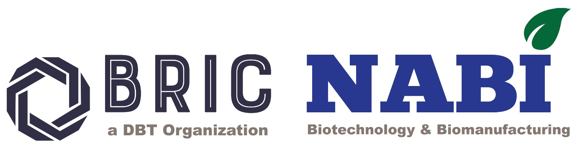

**NATIONAL AGRI-FOOD AND BIOMANUFACTURING INSTITUTE (BRIC-NABI)**

**(Dept. of Biotechnology, Ministry of Science & Technology, Govt. of India) Knowledge City, Sector 81, S.A.S. Nagar, Mohali 140306, Punjab, INDIA Website:** [**www.nabi.res.in**](http://www.nabi.res.in)

***Under the umbrella of***

**National Genome Editing and Training Centre (NGTEC)**

***Invites Application For Workshop***

***on***

*"Genome editing: Tools, experimental design and its applications"*

**(N*GETC NABI--Series-VI)***

***Application Form***

|  |  |
| --- | --- |
| ***Name of the candidate***  ***(In caps)*** |  |
| ***Date of birth*** |  |
| ***Gender*** |  |
| ***Current Designation*** |  |
| ***Current Affiliation*** |  |
| ***Official Address and Contact number with email:*** |  |
| ***Educational qualification: (Starting from Bachelor’s Degree onwards)*** |  |
| ***Ongoing area/s of research (<50 words)*** |  |
| ***Representative research Publications***  ***(if any; not more than five)*** |  |
| ***Details of previously attended genome editing/functional genomics workshop (if applicable)*** |  |
| ***Why you wish to attend the genome engineering workshop?*** |  |
| ***Letter of forwarding/support from the Head of your current institute/department/college etc. (As separate Annexure 1)*** |  |

**Date**

**Place Signature of the candidate**

**Instruction:**

1. *Candidates are requested to fill in the information above properly.*
2. *Candidates should attach the “Letter of forwarding/support from the Head of your current institute/department/college etc.” and merge the same with the application form as a pdf format and send the same at* [*ngetcnabi@gmail.com*](mailto:ngetcnabi@gmail.com) *on or before 30th May ,2025.*
3. *Limited seats (16) are available for the above workshop.*